HSE Training for Driving Safety Awareness
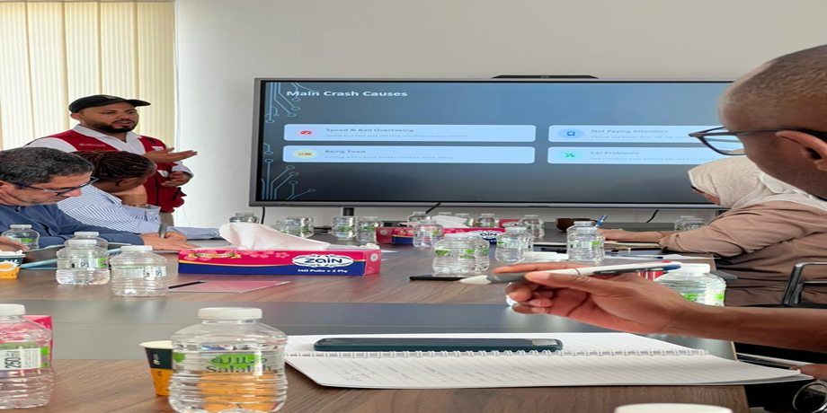
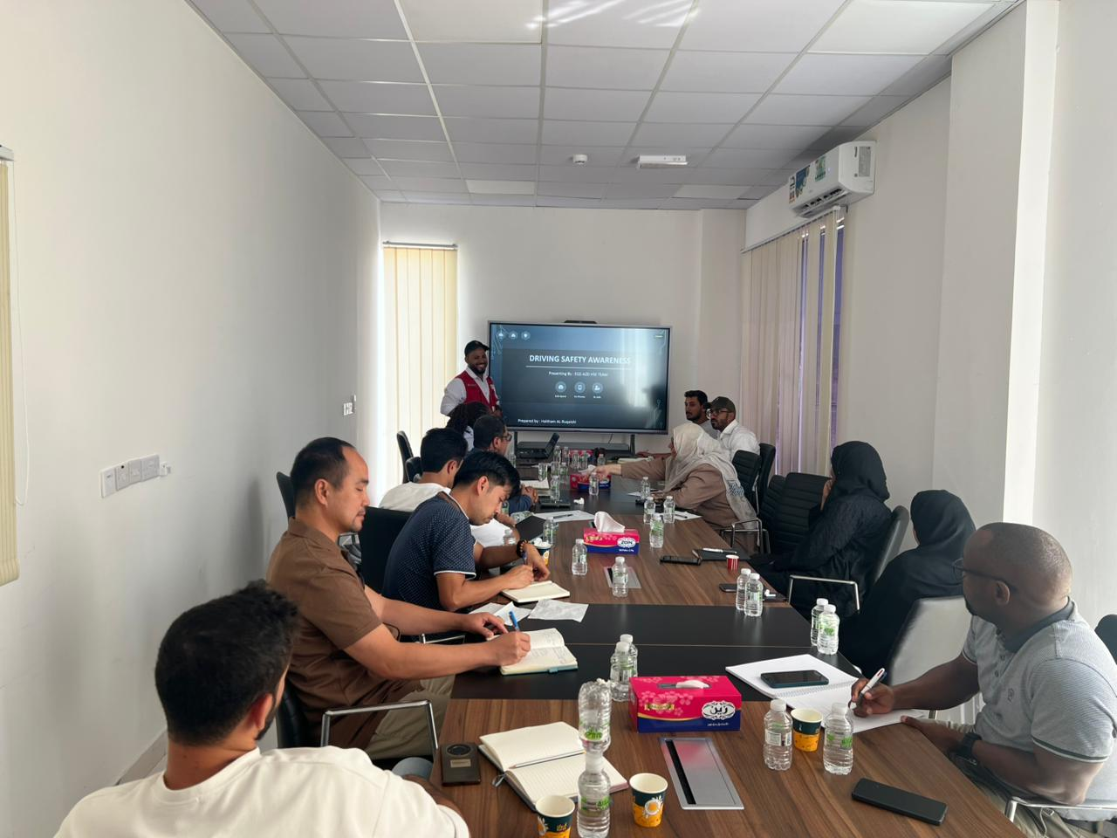
09/10/2025

Topic of Training | Driving Safety Awareness | Remarks
Conducted by | Haitham AL-Ruqaishi
Venue | Site office
Time | 12:00 PM
Total Attendance | 13
Language | English

Summary

Training Objective
The purpose of this training was to raise awareness on safe driving practices among project staff and drivers, aiming to prevent road accidents, ensure vehicle readiness, and promote a culture of responsible driving within the project.

Main Topics Covered
- Causes of Road Accidents: Overspeeding, unsafe overtaking, mobile phone usage, fatigue, and poor vehicle maintenance.
- Speed and Distance Rules: Importance of following the 120 km/h limit, adjusting speed in bad weather, and maintaining a safe 3-second distance between vehicles.
- Seatbelt & Mobile Policy: All occupants must wear seatbelts; mobile phone use (even hands-free) is strictly prohibited while driving.
- Fatigue Management: Avoid driving when tired; take breaks every two hours; share driving responsibilities on long trips.
- Vehicle Inspection: Daily checks of lights, brakes, tires, mirrors, and fluid levels before driving.
- Weather Precautions: Safe driving practices during rain, dust storms, and night driving — slow down, increase visibility, and avoid flooded areas.
- Defensive Driving: Stay alert, anticipate other drivers’ mistakes, keep both hands on the steering wheel, and maintain full focus on the road.

Key Message
“Work Safe – Drive Safe – Go Home Safe.”
The training emphasized that every trip matters and safety starts before starting the engine.

Outcome
Participants actively engaged in the discussion and understood the importance of following safe driving rules. The session improved awareness about accident prevention, fatigue control, and vehicle safety inspection.

Recommendations
- Continue conducting short monthly toolbox talks on driving safety.
- Regularly inspect project vehicles and maintain safety check records.
- Enforce seatbelt and mobile phone compliance for all drivers.

